Better Life Medical & Chiropractic
Better Life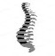Better You

Back Exercises

These exercises should only be performed after evaluation by a qualified medical professional and under their instruction. Failure to properly ascertain the reasons for certain injuries or causes of pain may lead to further injury if these exercises are performed.
If you experience pain or discomfort while doing an exercise, stop immediately. Follow only the exercises that your doctor has recommended to avoid the potential of further injury.

Nose – to – knee
Purpose:
To strengthen abdominal muscles and to increase low back range of motion.
Steps:
- Begin by laying on your back
- Pull right knee to chest with both hands as tightly as is comfortably possible.
- Raise your head and touch your nose to your knee
- Hold for 5 seconds
- Repeat steps 1-4 on left leg
- Repeat steps 1-4 with both knees
Tips:
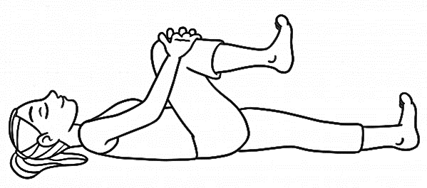
Keep your low back touching the floor
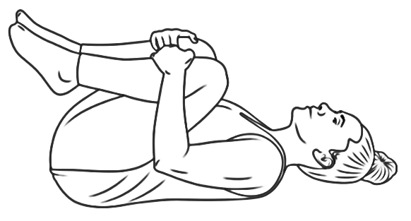

Piriformis Stretch
Purpose:
To stretch buttock (piriformis) muscle.
Steps:
- Begin by laying on your back and lifting you left leg with your knee bent.
- Grasp left leg with right hand over or under the ankle. Place left hand on outside of left knee.
- Bring left knee towards midline of your chest.
- Slowly increase pressure on ankle using right hand. Feel the stretch in your buttock.
- Hold for 3-5 seconds
- Repeat with right leg.
Tips:
Keep your knee in line with your nose.
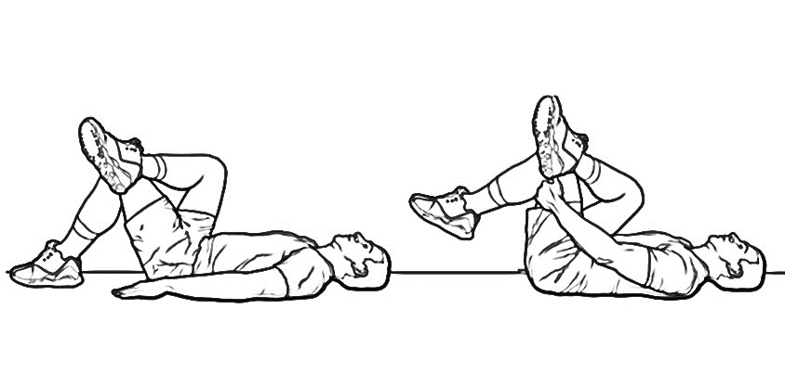

Cross- over stretch:
Purpose:
To stretch the lower back.
Steps:
- Start on your back with your hands by your side
- Pull your right leg up and cross it over your body until you feel a gentle stretch through your lower back
- Hold for 15-20 seconds
- Repeat on left leg
Tips:
Try to keep both shoulders on the ground.
